**AWS VPC Project for Resume 05/08/23**

**Anand Reddy**

Create a VPC that you can use for servers in a production environment.

To improve resiliency, you deploy the servers in two Availability Zones, by using an Auto Scaling group and an Application Load Balancer.

For additional security, you deploy the servers in private subnets.

The servers receive requests through the load balancer.

The servers can connect to the internet by using a NAT gateway.

To improve resiliency, you deploy the NAT gateway in both Availability Zones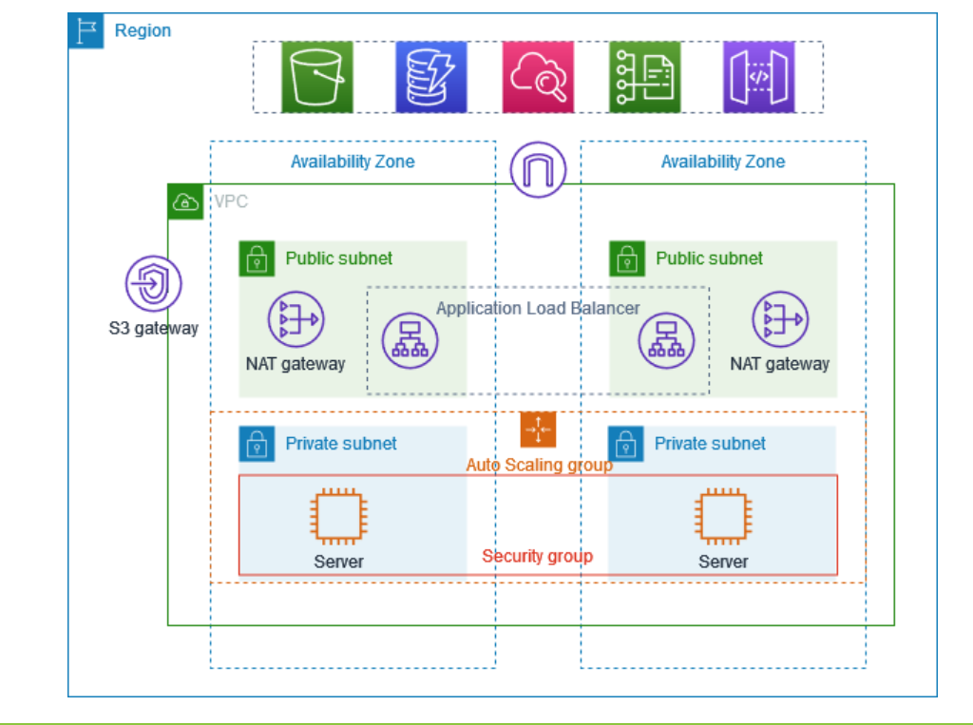

Step 1a: Create a VPC that you can use for servers in a production environment.

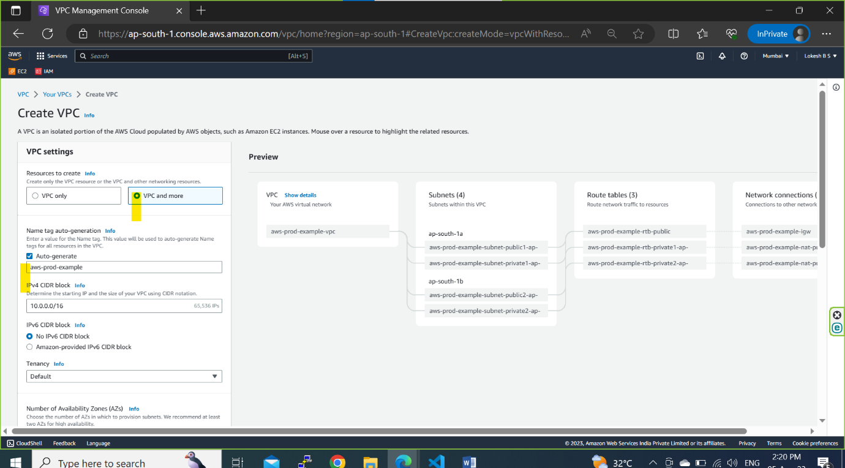

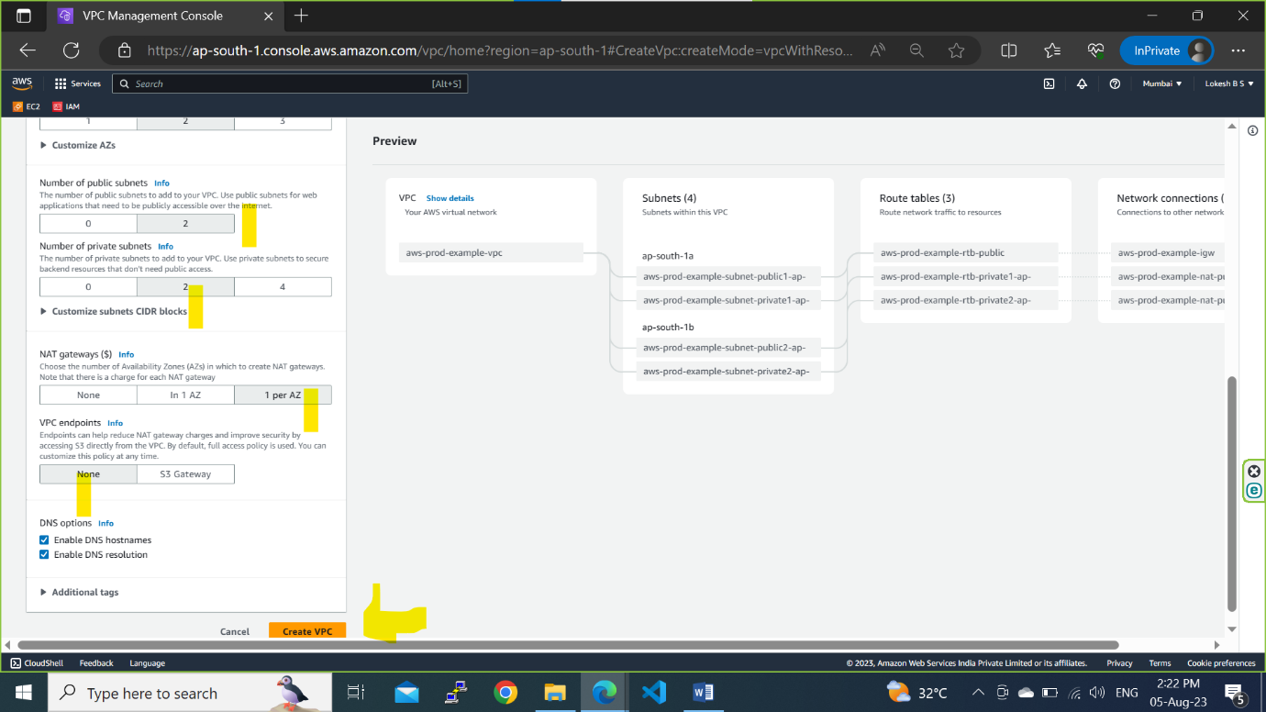

**Step1b: Preview**

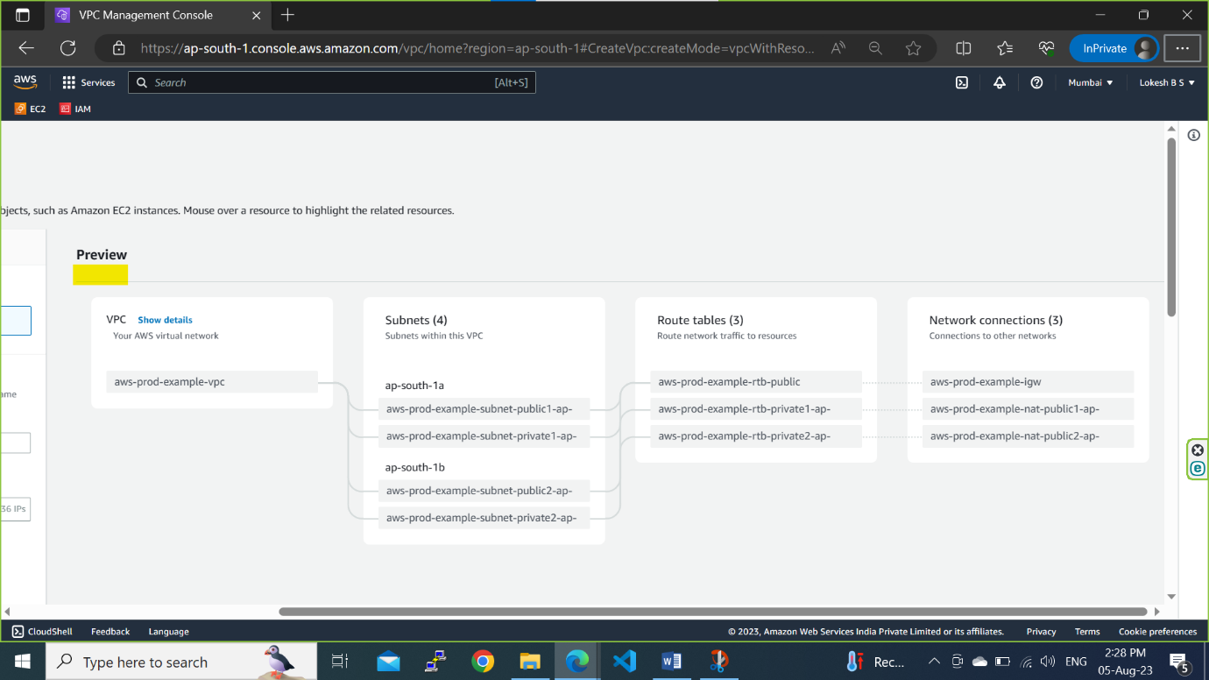

**Step1c: VPC has created successfully**

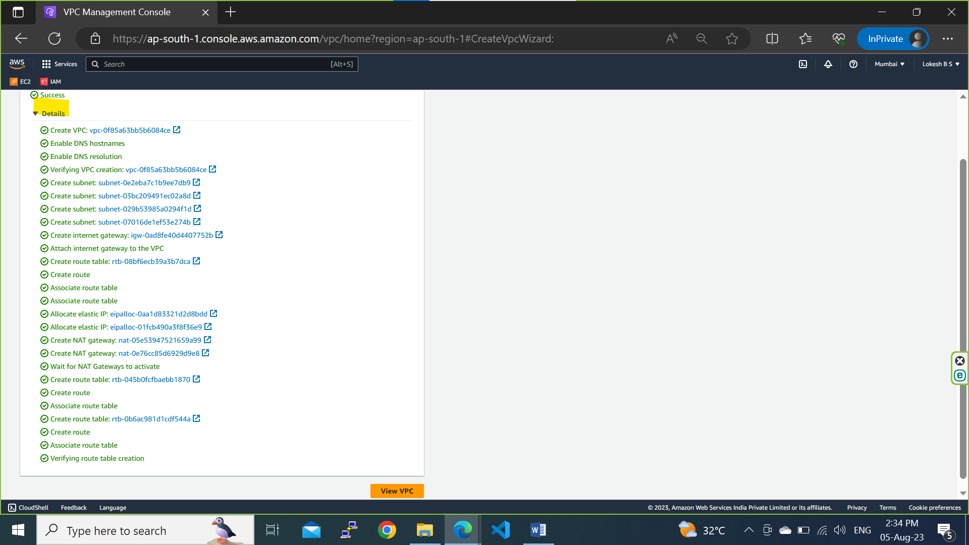

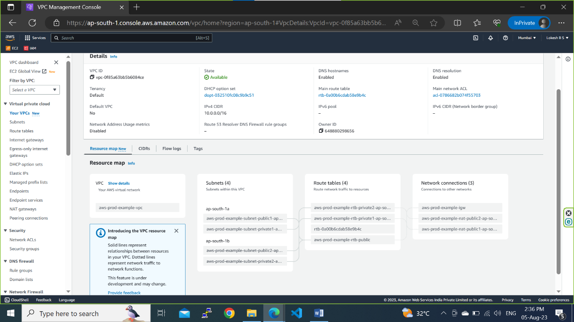

**Step 2a:** To improve resiliency, you deploy the servers in two Availability Zones, by using an Auto Scaling group and an Application Load Balancer.

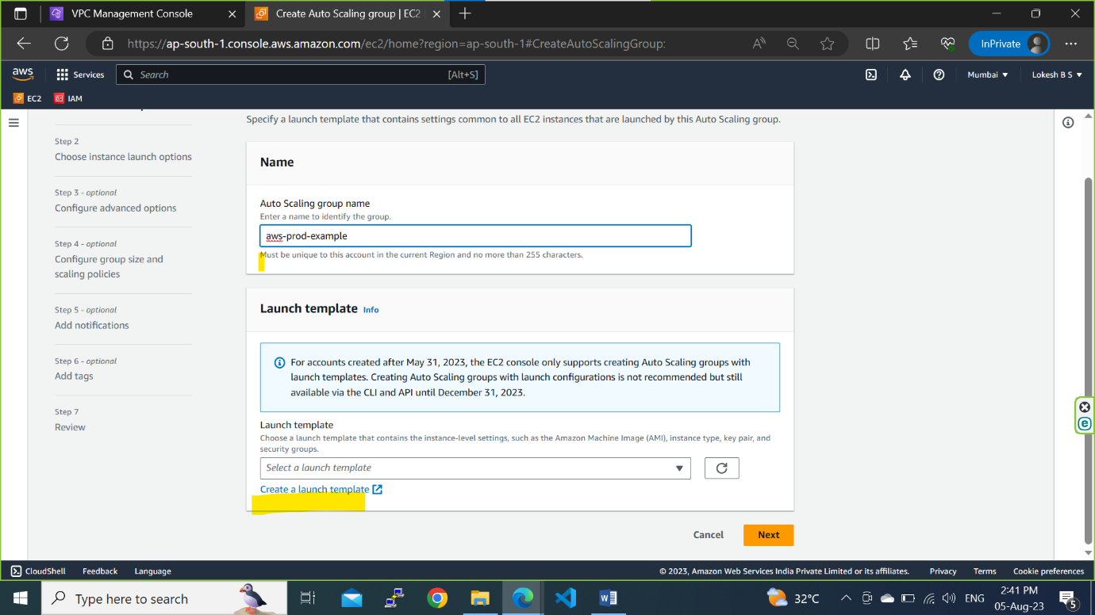

**Step2b: Give a Template name**

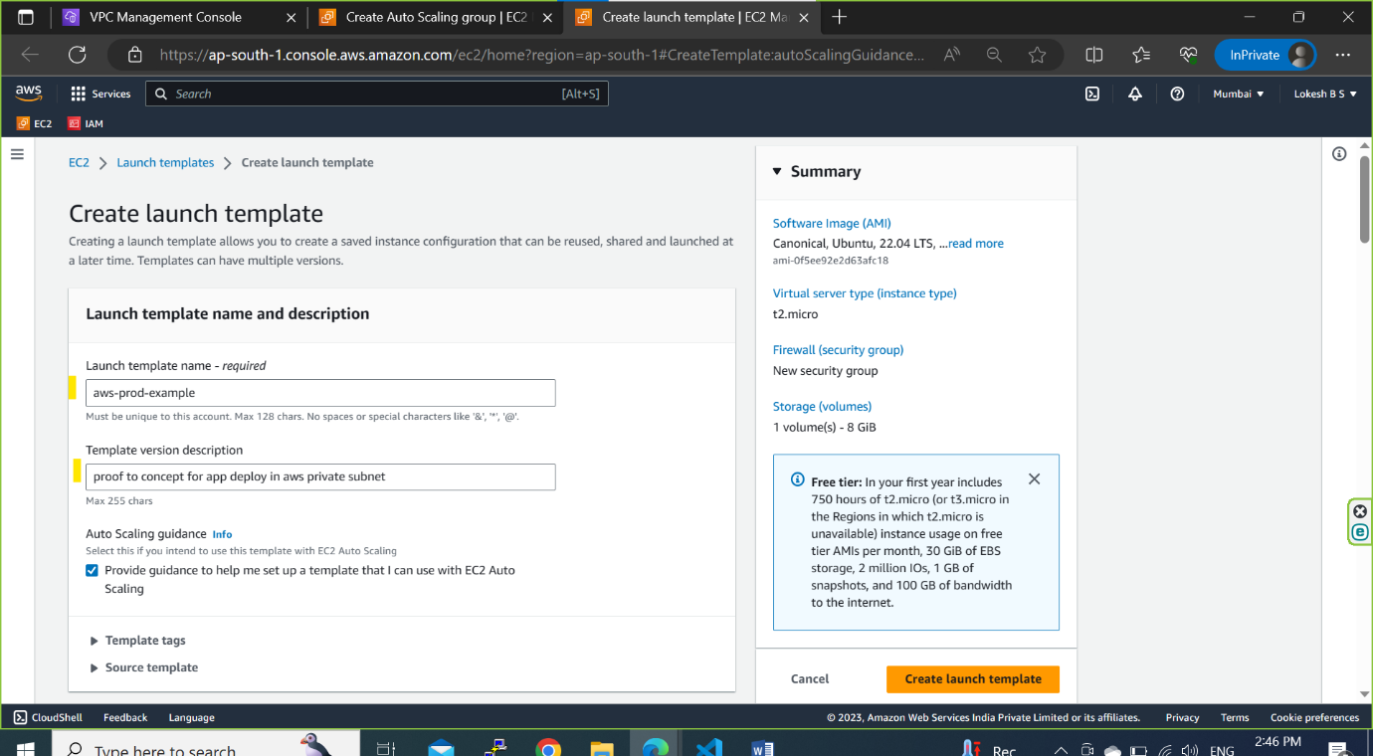

**Step2c: Select the instance type**

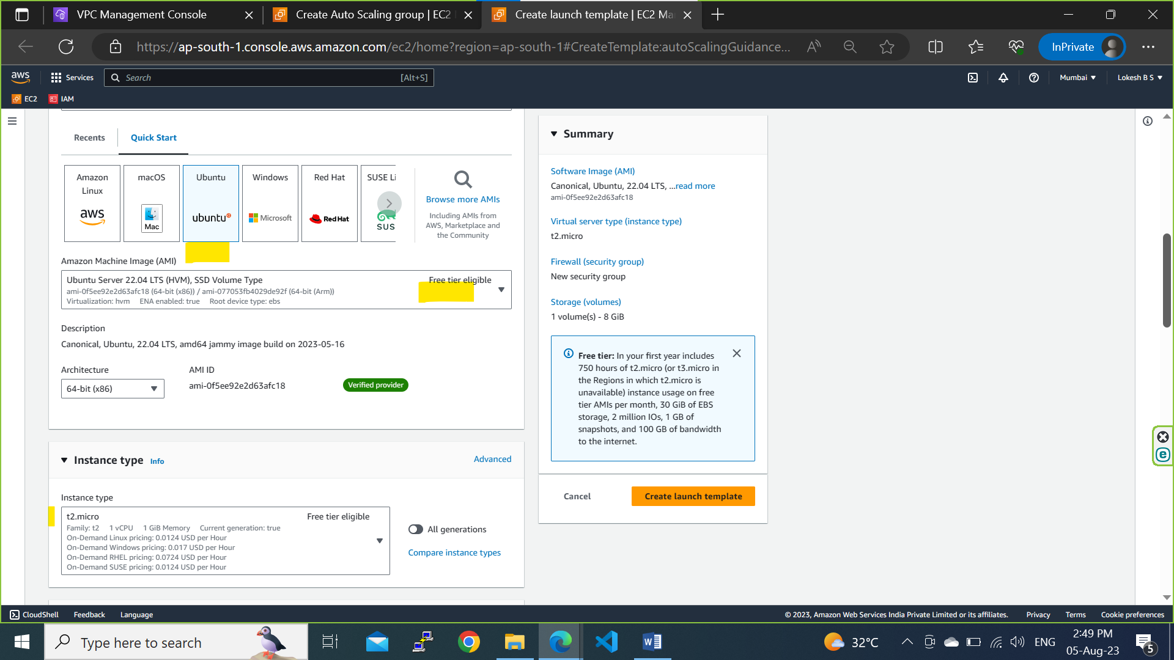

**Step2d: Provide network details and click on create launch template**

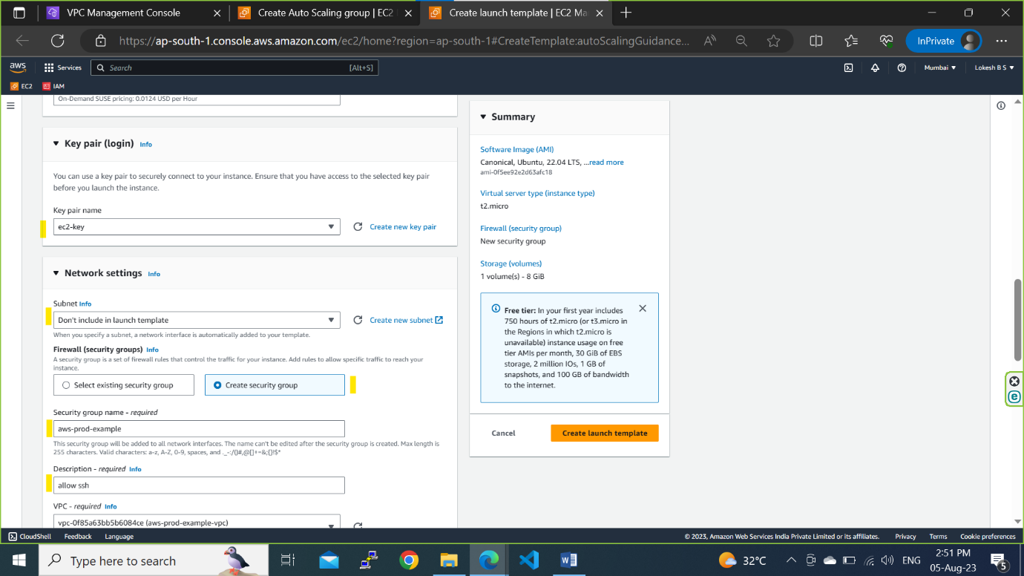

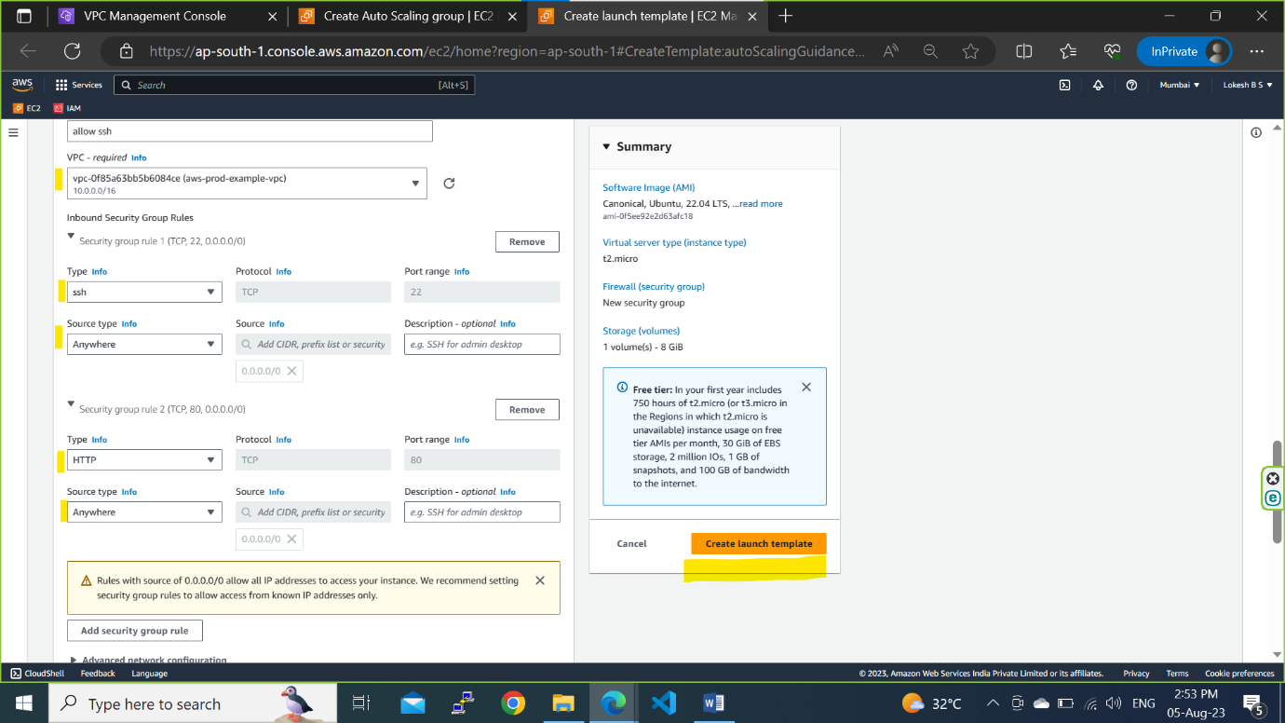

**Step2e: Select the created template and click on Next**

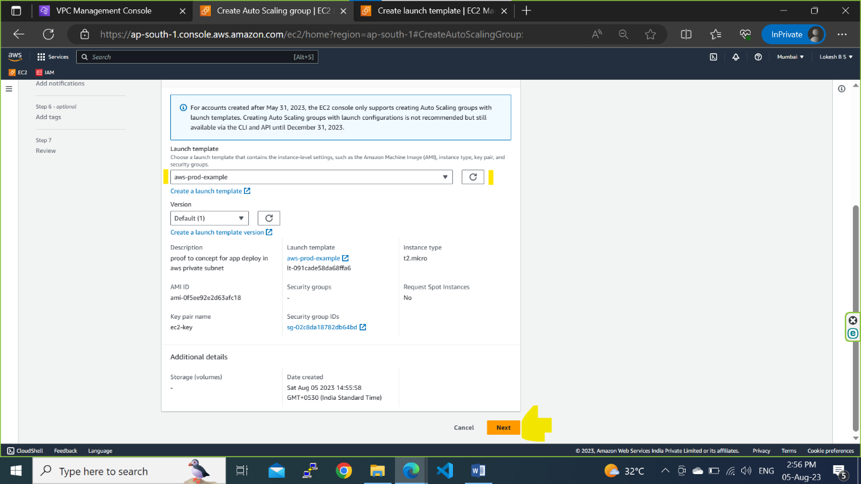

**Step2f: Select the created VPC and select only private subnet for deploying the simple python application and click on Next**

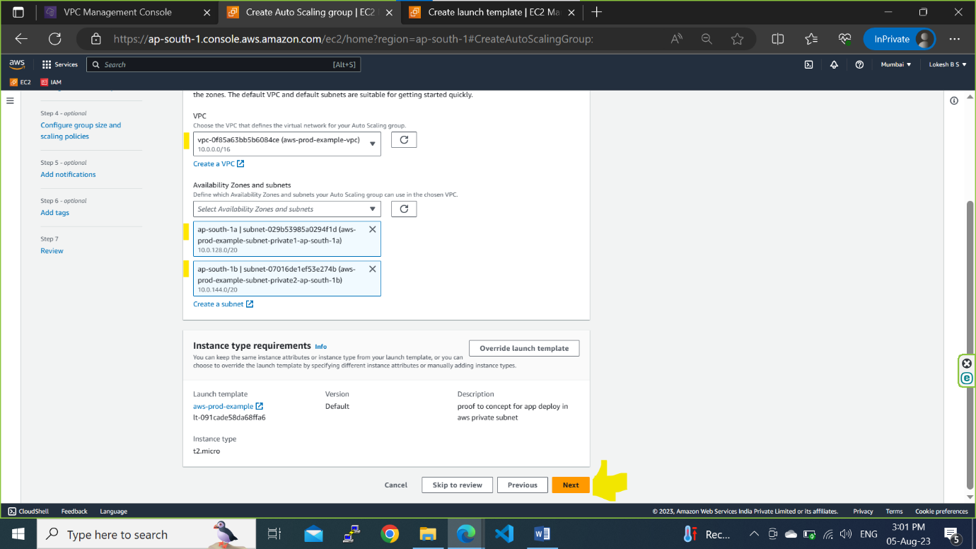

**Step2g: Don’t attach the load balancer here just click on Next**

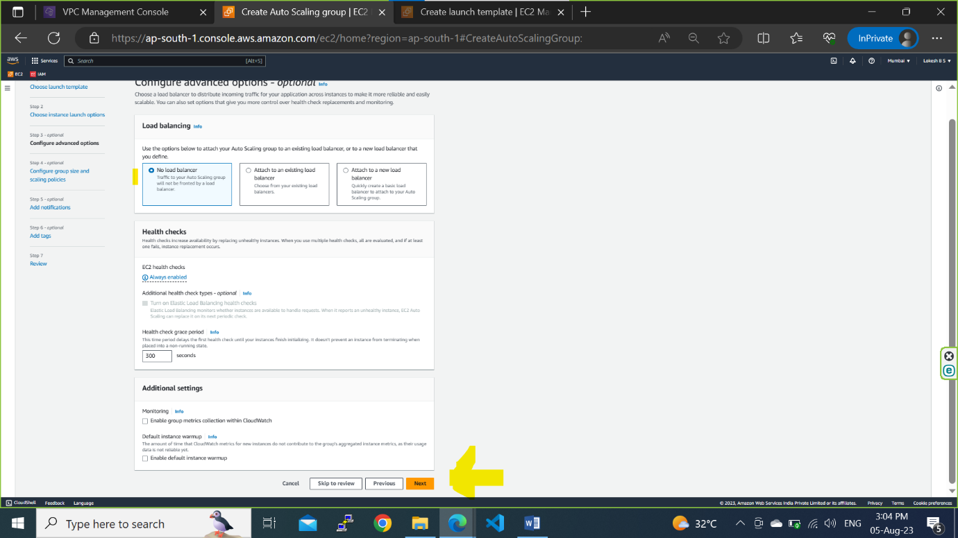

**Step2h: Provide the instance capacity and click on Next**

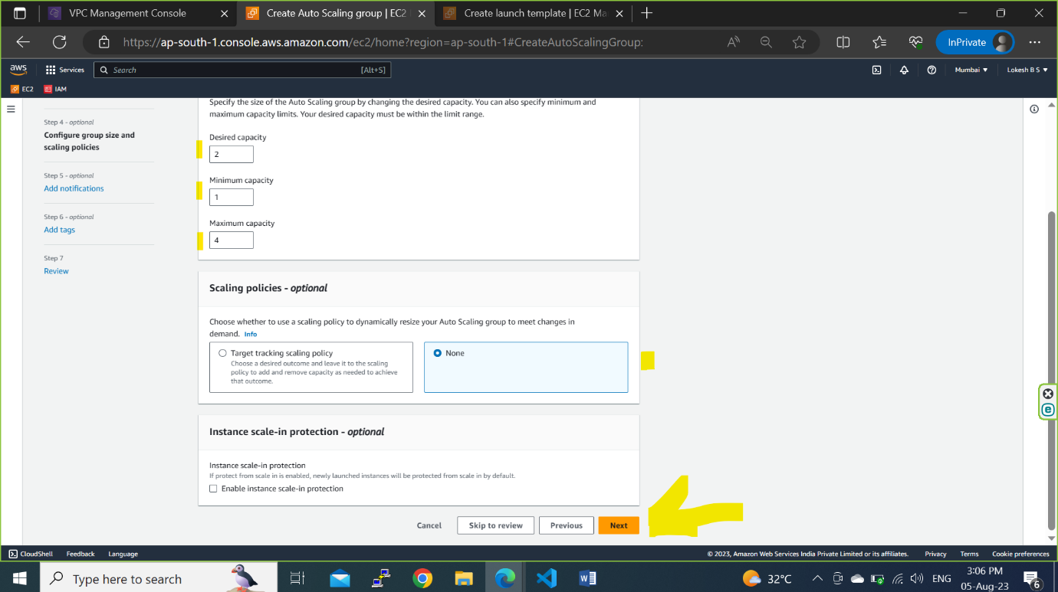

**Step2i: You can add the notification here**

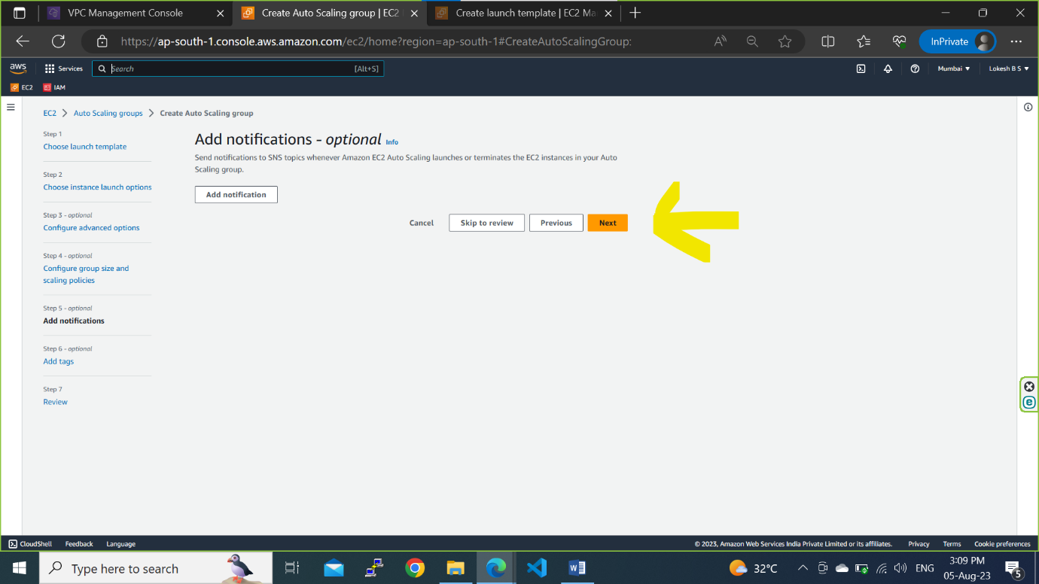

**Step2j:You can add the tags here**

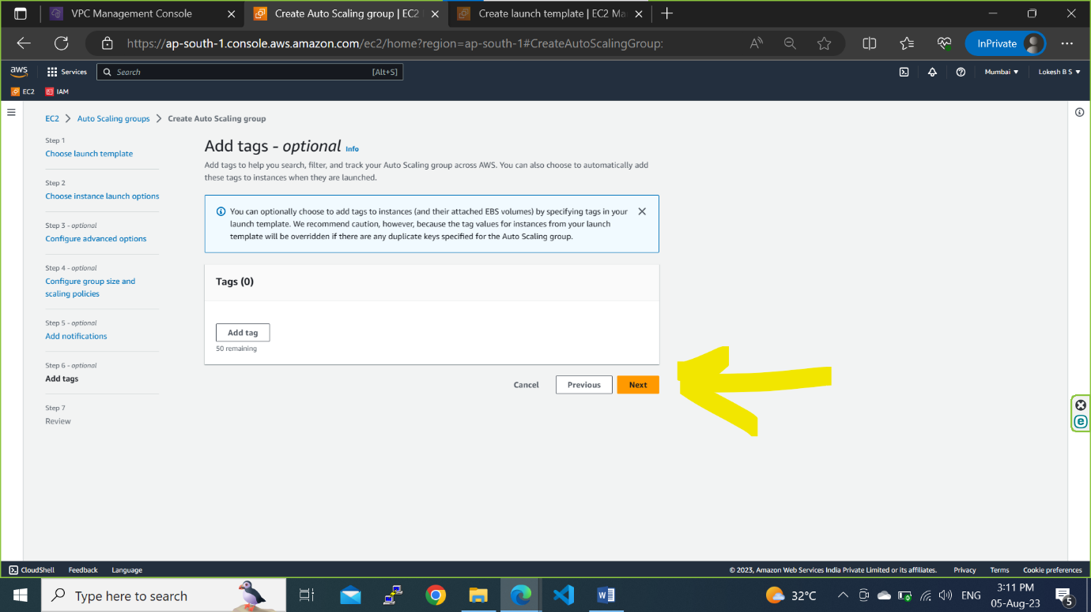

**Step2k: Review and click on Create Auto Scaling Group**

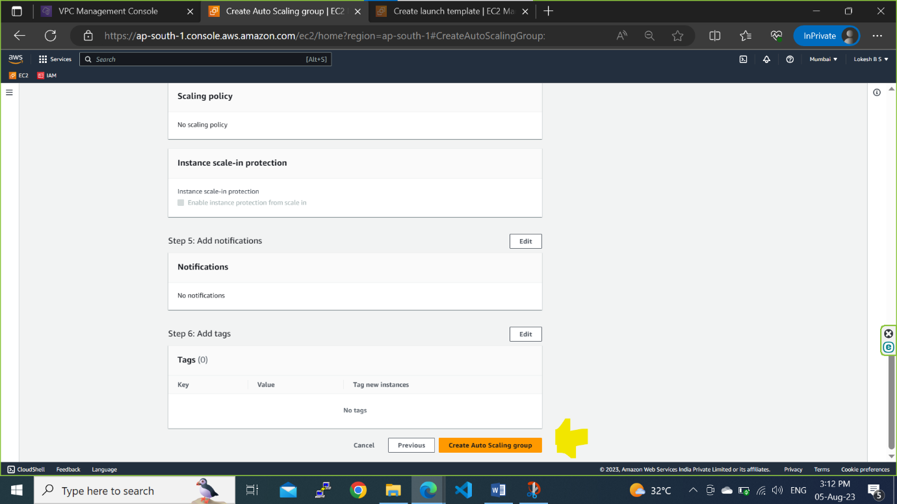

**Step2l: Auto Scaling Group created successfully and launched a 2 private instances automatically as mentioned in desired capacity**

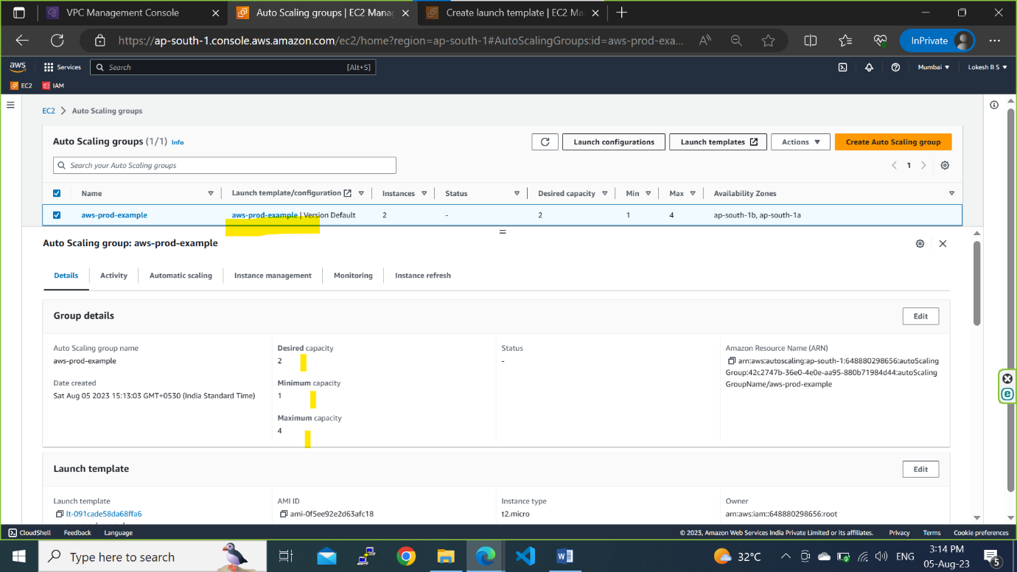

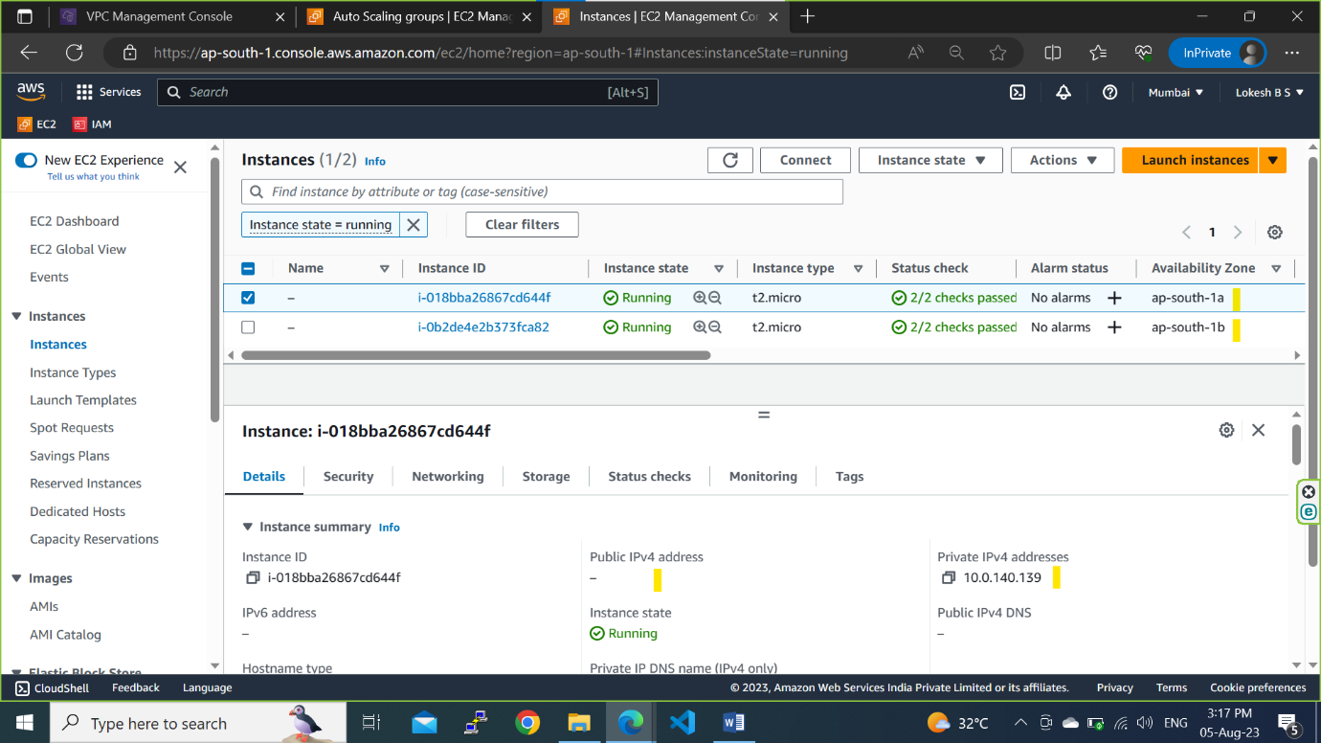

**Step3a: Create a bastion Host or Jump Server to connect the Private servers through SSH to deploy a Simple Python Application.**

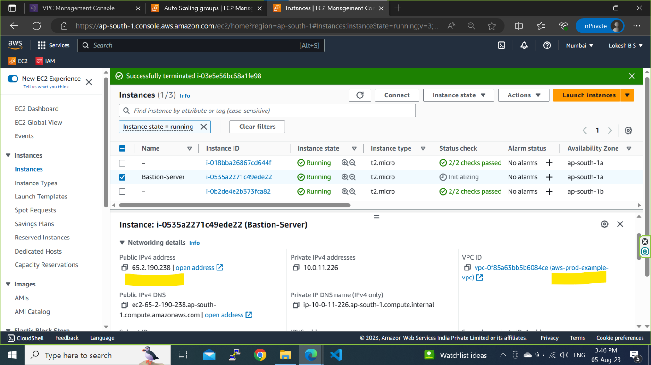

**Step3b: Copy the private server pem key into the bastion server to connect to private server from bastion server through ssh**

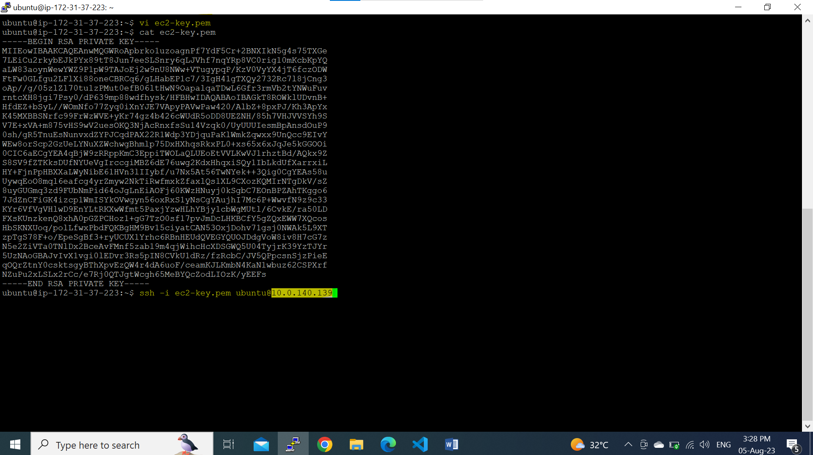

**Step 3c: Once connected to the Private server get a simple python code from online for testing.**

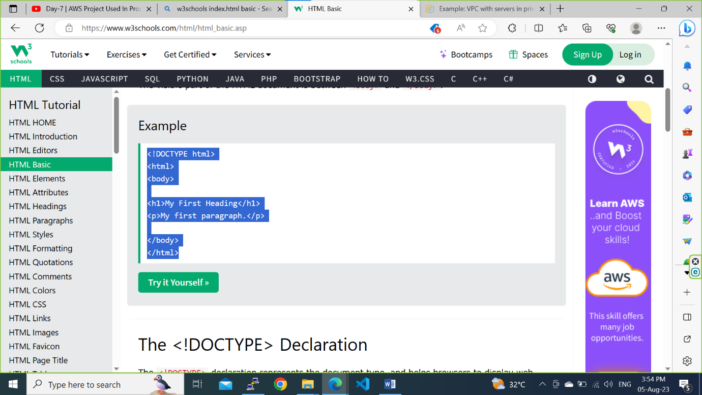

**Step 3d: create a index.html file and paste the code. Simillary connect to the another private server using a bastion server through SSH and paste the python code in index.html**

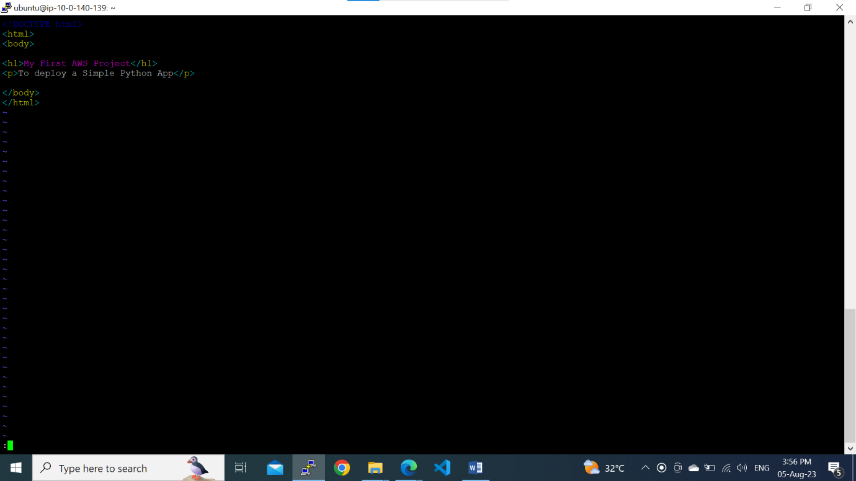

**Step 4a: create a Application Load Balancer to distribute the traffic to the both private servers through public subnet.**

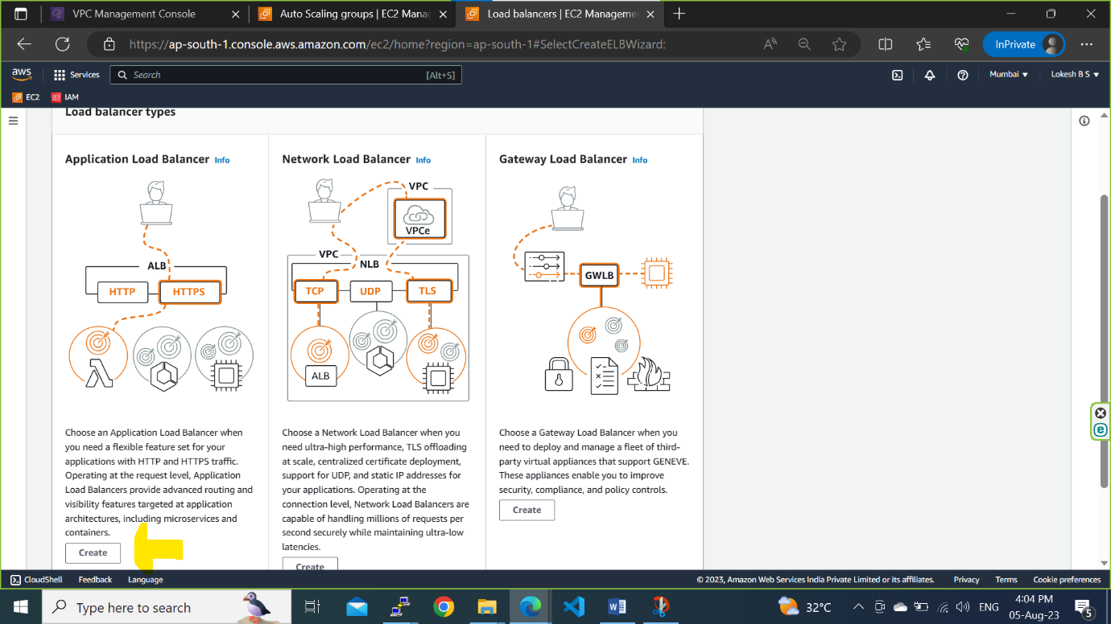

**Step 4b: Give the load balancer details and select the internet facing.**

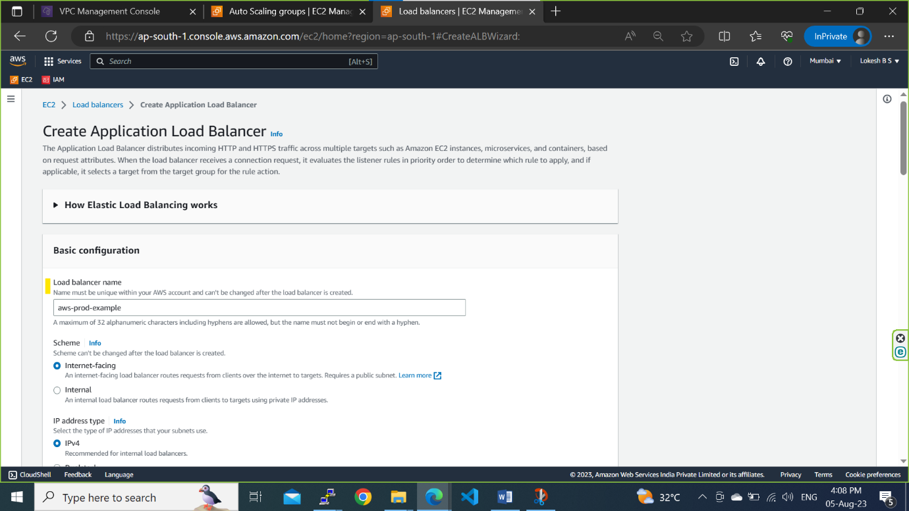

**Step 4c: In network mapping select only public subnets to allow the traffic.**

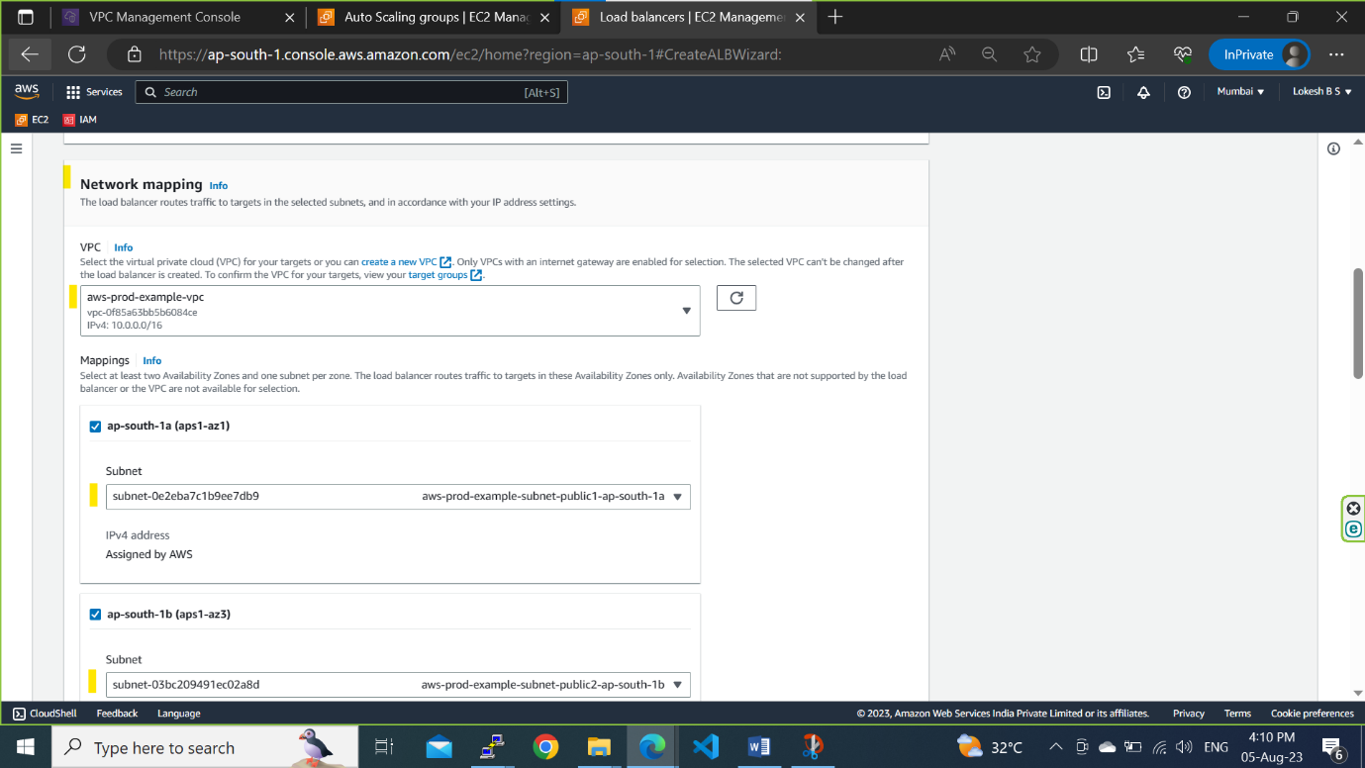

**Step 4d: Create a target Group**

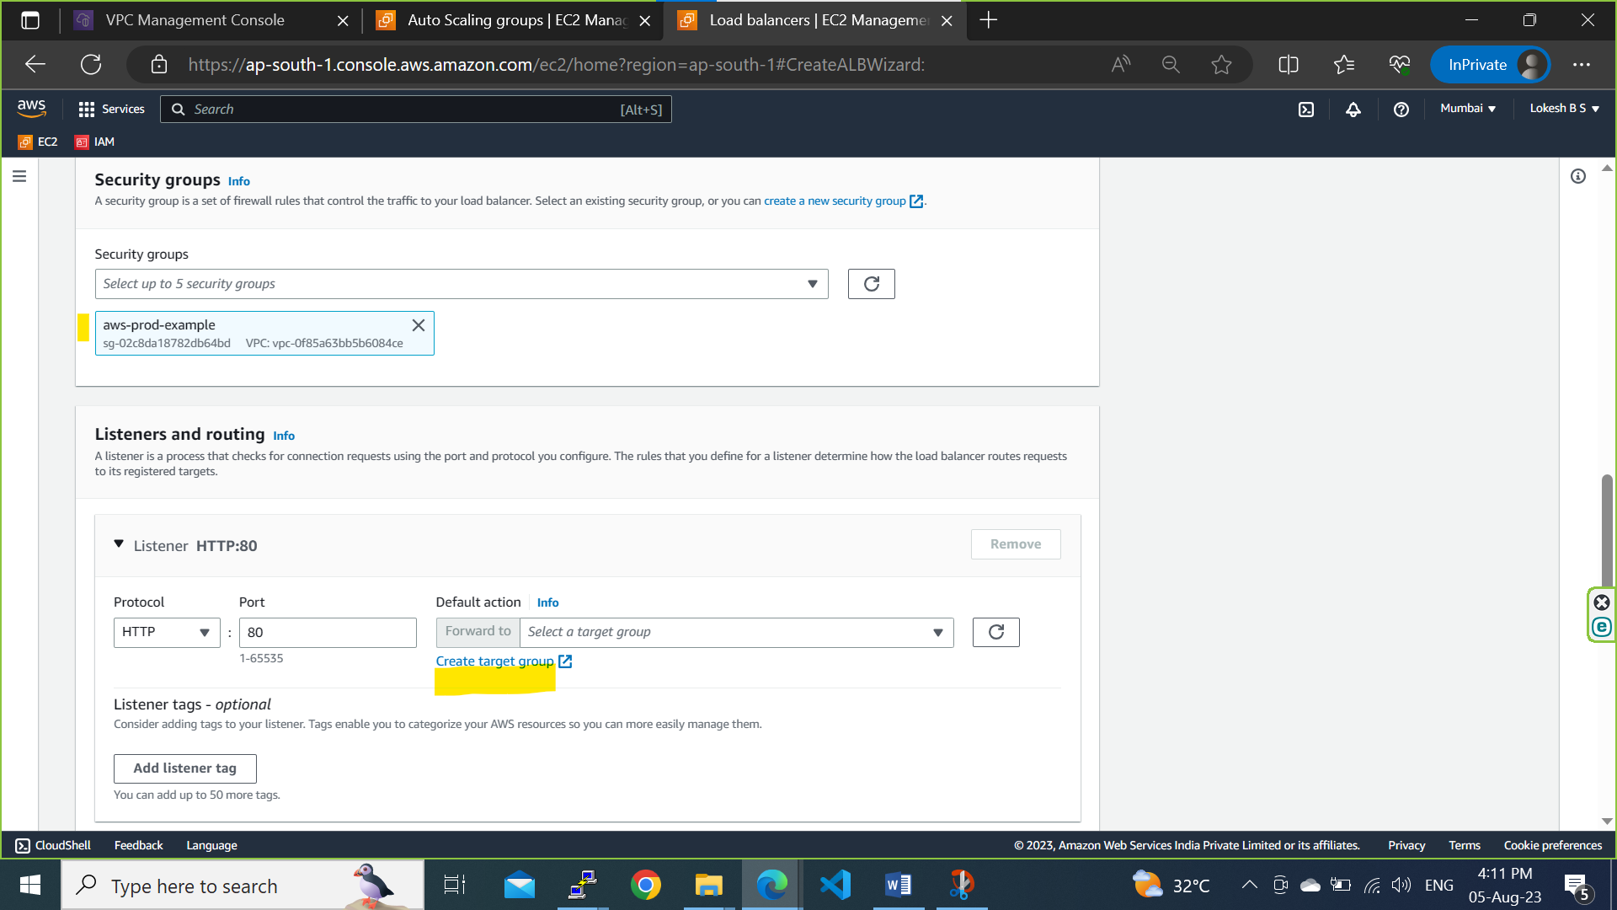

**Step 4e: Choose target type as Instance and allow port 8000 to run python and connect application.(you can use your own port number here) and click on Next**

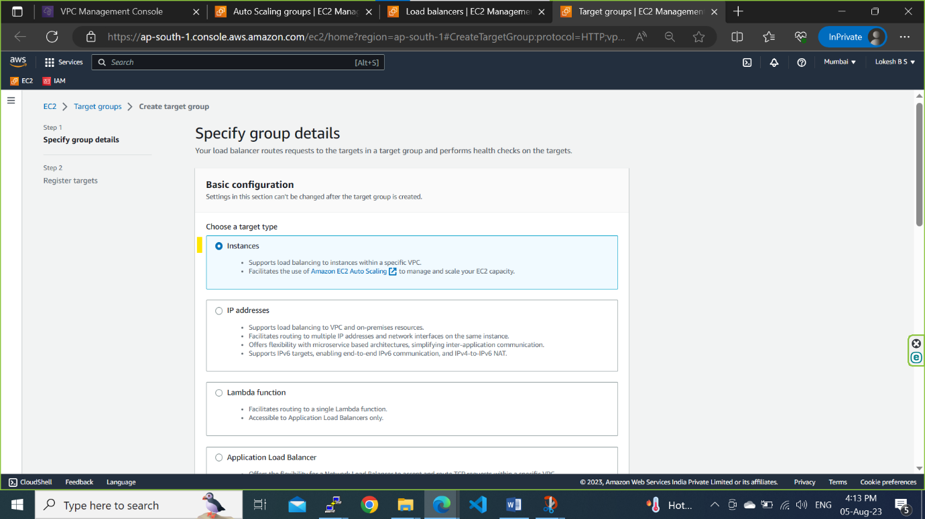

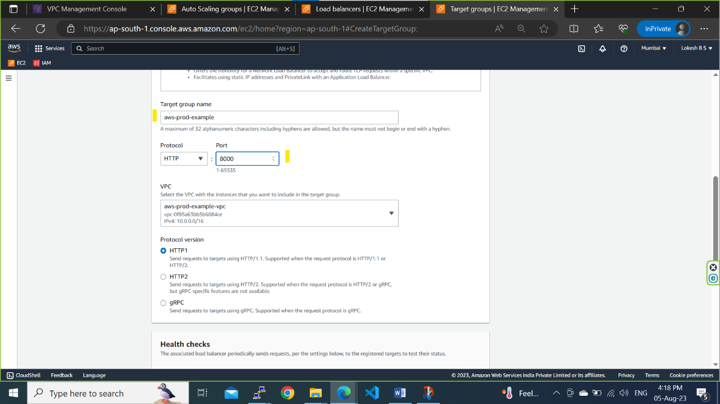

**Step 4f: Select Private servers where python app is deployed and click on include as pending below and click on Create target group**

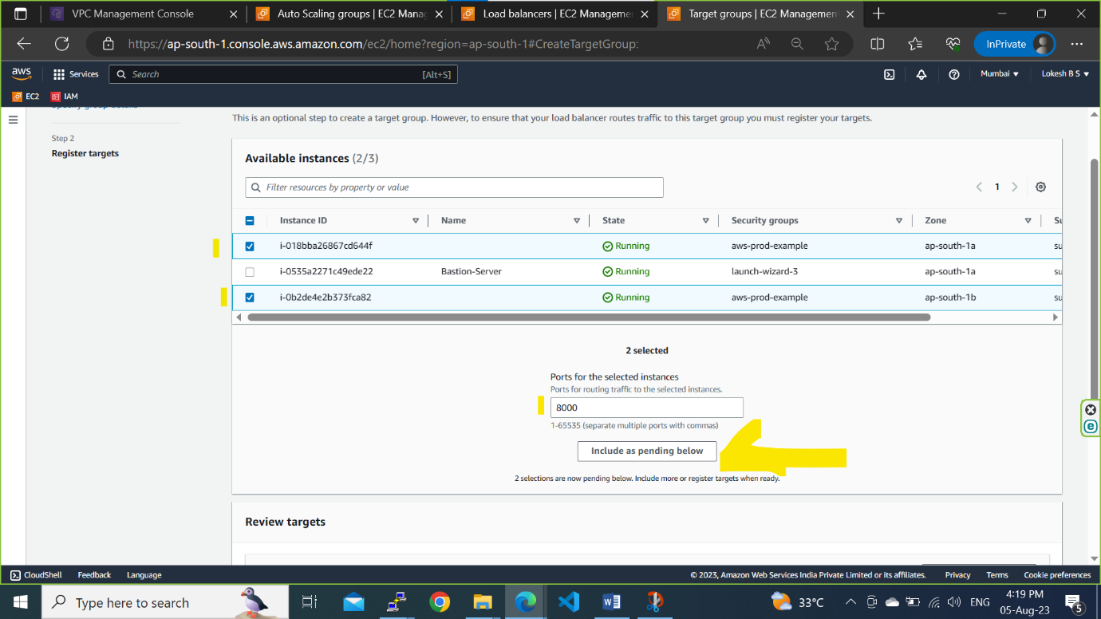

**Step 4g: select the created taget group in Load balancer and click on Create Load Balancer**

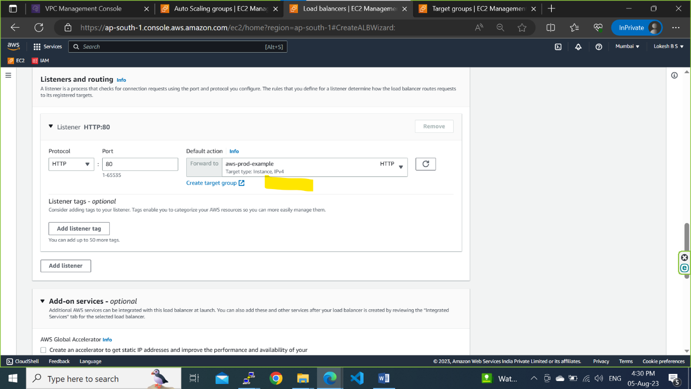

**Step 5a: Run the python application in private servers.**

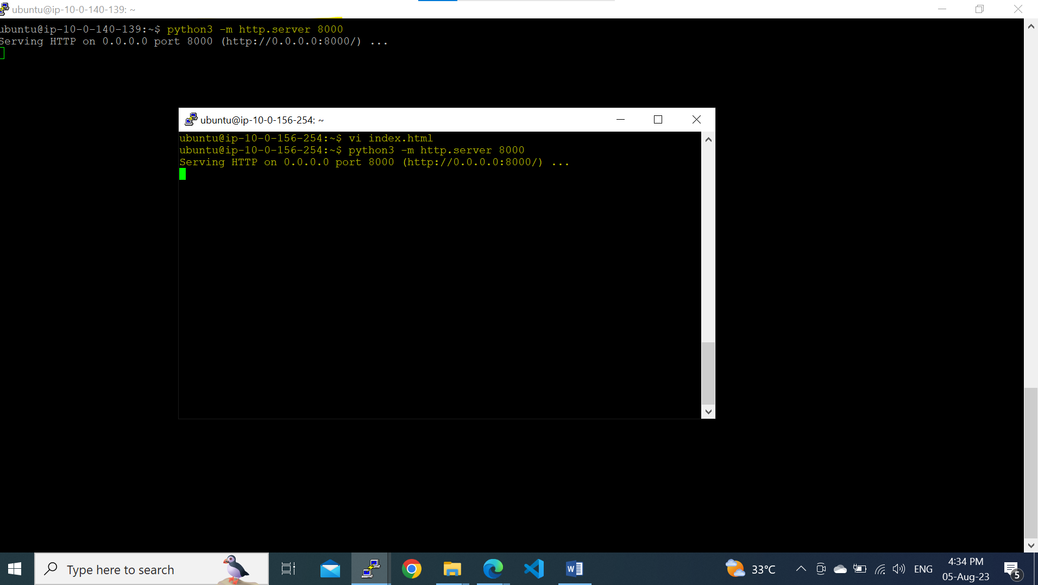

**Step 5b: Copy the DNS and paste it on web browser.**

